**Ain Shams University**  
**Faculty of Computer & Information Sciences**

**Computer Science Department**

**Data Science Project Documentation**

**Project Idea:**

**“Household Income Analysis”**



Under Supervision of:

**Dr. Abeer Mahmoud**

[Team Number: 39]

**Team Members:**

**1st** Team Member Name:

Kareem Saeed Ragab

**1st** Team Member ID:

2018170282

**1st** Team Member Department:

Computer Science

**2nd** Team Member Name:

Nada El Sayed Anies

**2nd** Team Member ID:

2018170430

**2nd** Team Member Department:

Computer Science

**Part #1:** “Review of Big Data Analytic Methods”

1. **Step # 1:** Retrieve and Clean Up Data using R

**1.1- Analyze the data:**

* The screenshot from the R code.

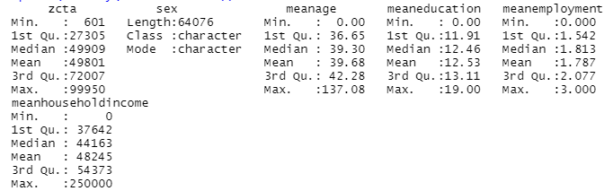

* Columns names: zcta , sex , meanage , meaneducation , meanemployment

**1.2- Number of rows in the zeta table**:

* 64076

**1.3- Are there any duplicated rows of data in the zeta table?**

* There is no duplicated rows of data.

**1.4- According to 1.3, no duplicated rows.**

**1.5- According to 1.3, no duplicated rows to save it in the new table.**

1. **Step # 2:** Data Analysis in R

**2.1- Loaded the data, Included in the R code.**

**2.2- Changed the column names, Included in the R code.**

**2.3- What are the mean and median average incomes?**

* Incomes column mean: 48245
* Incomes column median: 44163

**2.4- Plot a scatter plot of the data?**

* The scatter plot from the R code.

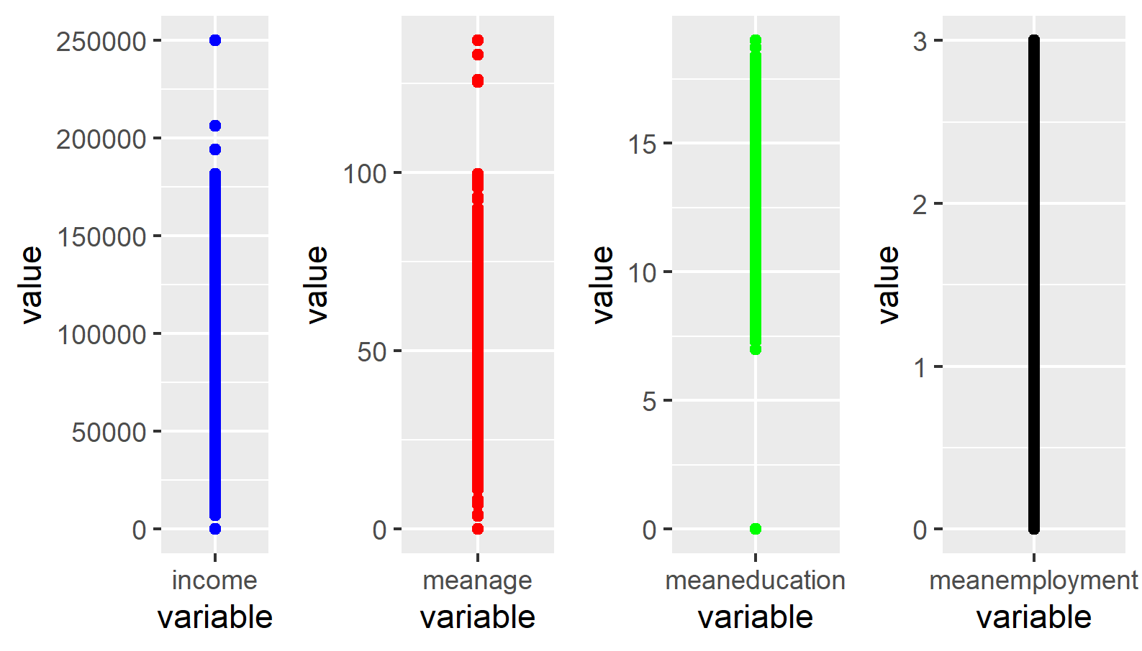

* **Do you have any outlier values?**

YES

* **What are these outlier values?**

In incomes and meanage columns in range more than 200,000 (>200,000) and less than 7,000 (<7,000) as shown in the plot.

**2.5- Deleting the outlier values, Included in the R code.**

**2.6- The mean of the data:**

* The mean before deleting the outlier values: 48245.24
* The mean after deleting the outlier values: 48464.95

**3. Step # 3:** Visualize your data

**3.1- Create a box plot of the data?**

* The screenshot from the R code.

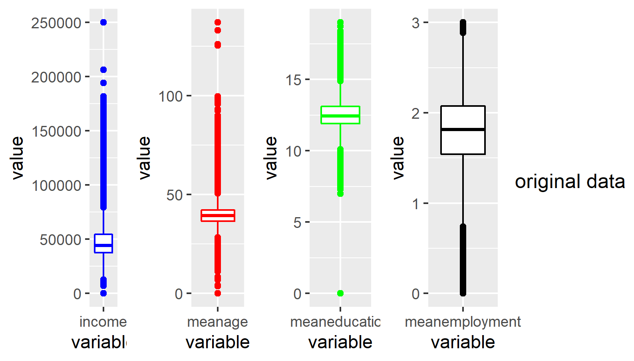

**3.2- Create a box plot of the data with the (log scale)?**

* The screenshot from the R code.

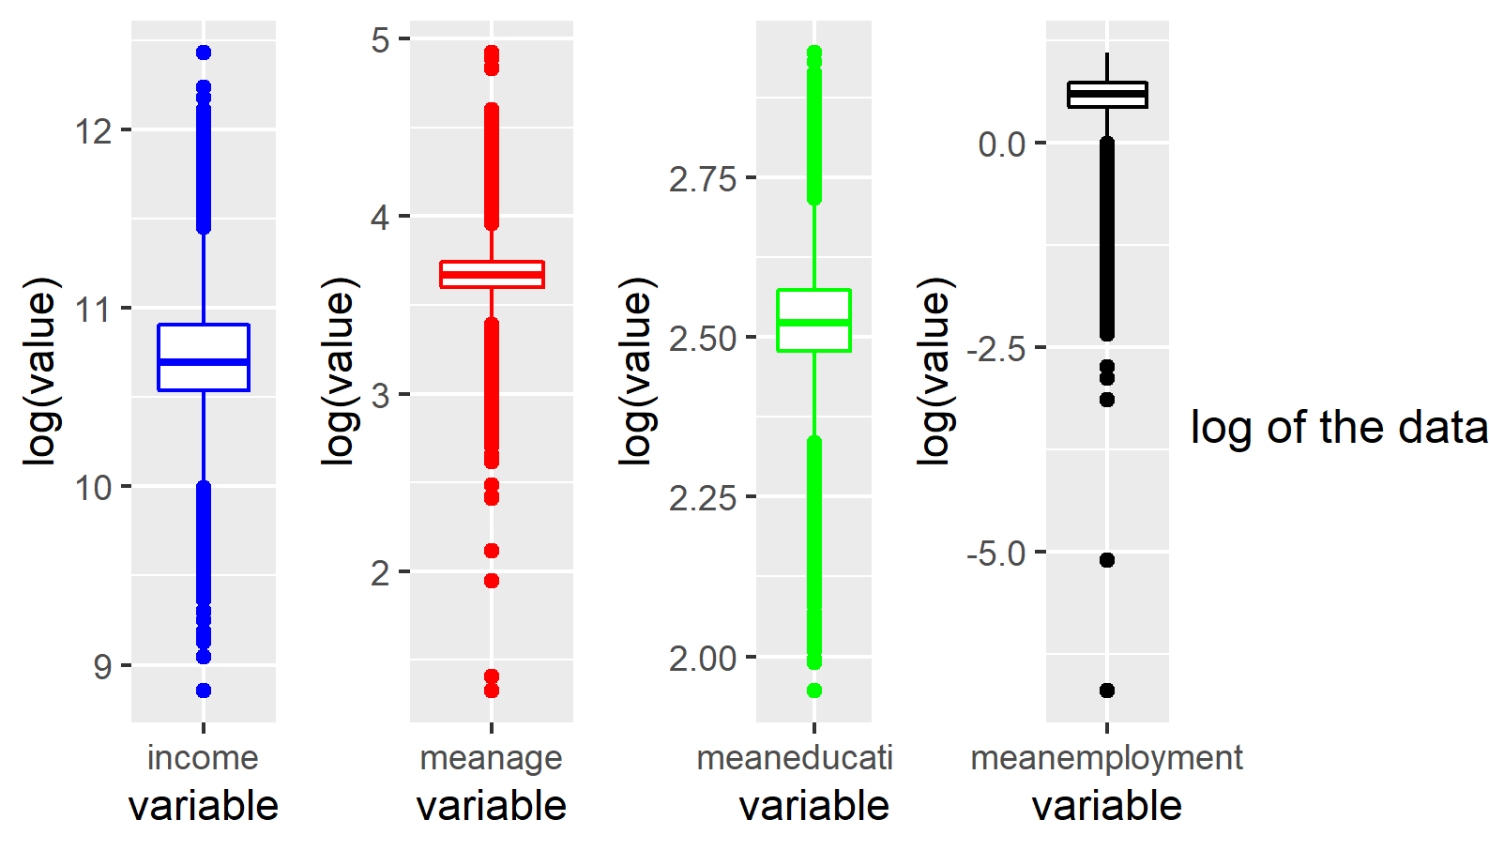

**3.3- What can you conclude from this data analysis/visualization?**

* In the end of the part #1 of data analysis/visualization, it’s important to do preprocessing for the data to study and clean it from any duplicated data and outlier values to help you in the next process such as (K-means clustering).

**Part #2:** “Advanced Analytics/Methods (K-means)”

1. **The table is created, Included in the R code**
2. **Cluster the data using K-means and plot the result?**

* The plot screenshot from the R code, **Note** K = 10 :

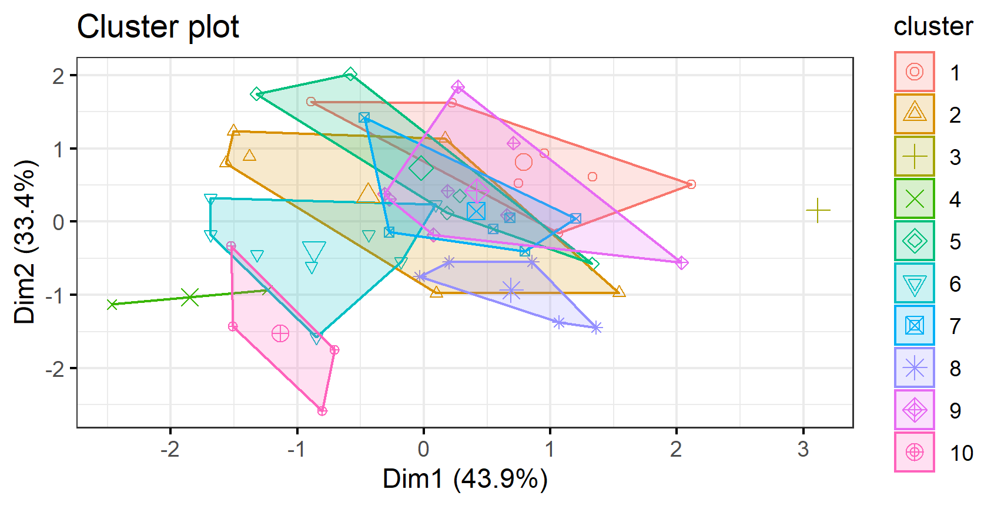

1. **Determine the reasonable value of k using (elbow)?**

* Within cluster sum of squares plot

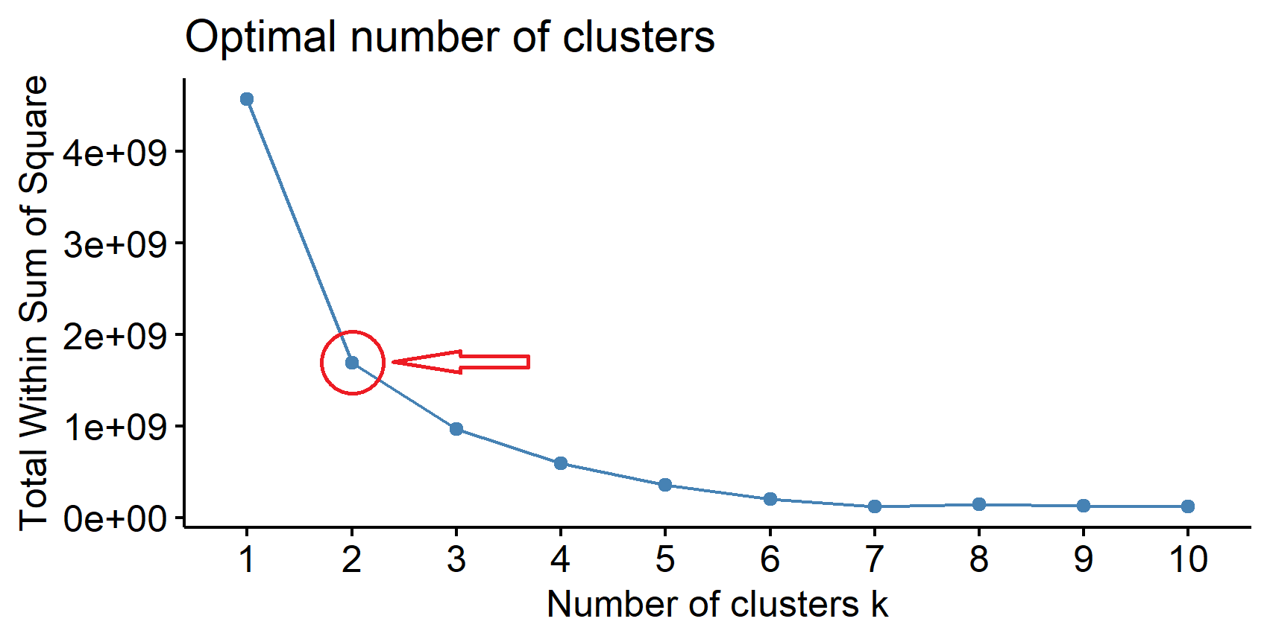

* As shown in the elbow plot above the best K value in the clustering using K-means equal 2.

1. **Cluster the transformed data to (log10 scale) using K-means and plot the result?**

* The plot screenshot from the R code, **Note** K = 10 :

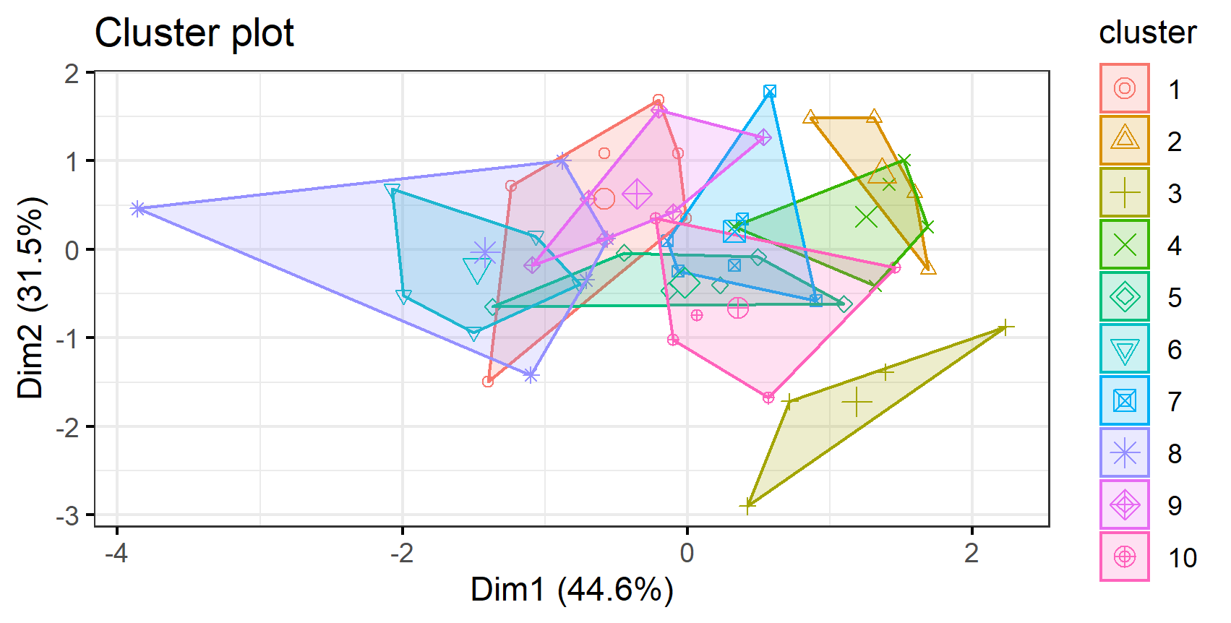

* The clustering grouping changed with all the points grouped to a cluster. Before scaling the data, there are points some of them take one cluster with its own, so it will lead to overfitting.
* **Why?** Because the scaling the data with log10 distributes the data with each other and distance between them became less, so the K-means algorithm work again with the updated data.

1. **The elbow plot after scaling data with log10**

* Within cluster sum of squares plot

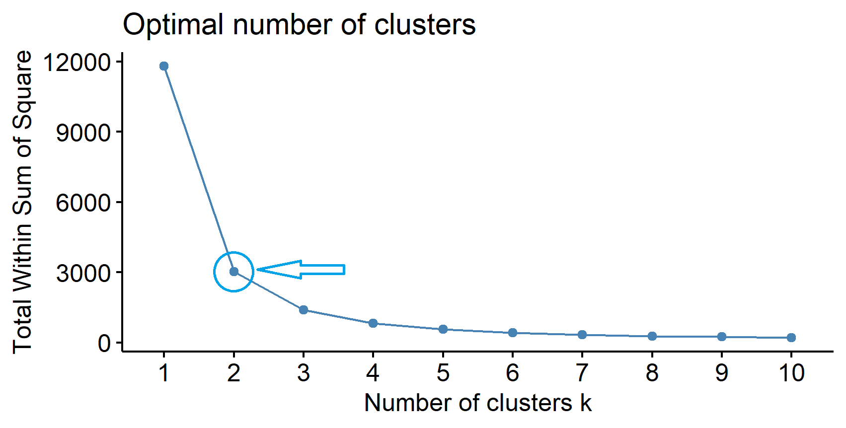

* Still the best choice of K equal 2. According to the elbow plot above.

1. **Have you observed an outlier in the data?**

YES

**6.1- Calculated the outlier values by two ways:**

* **Theoretically:** to get the rows of outlier values from the dataset.

The outlier values exists in the rows: 32, 20, 41, 7, 17

* **Graphically**

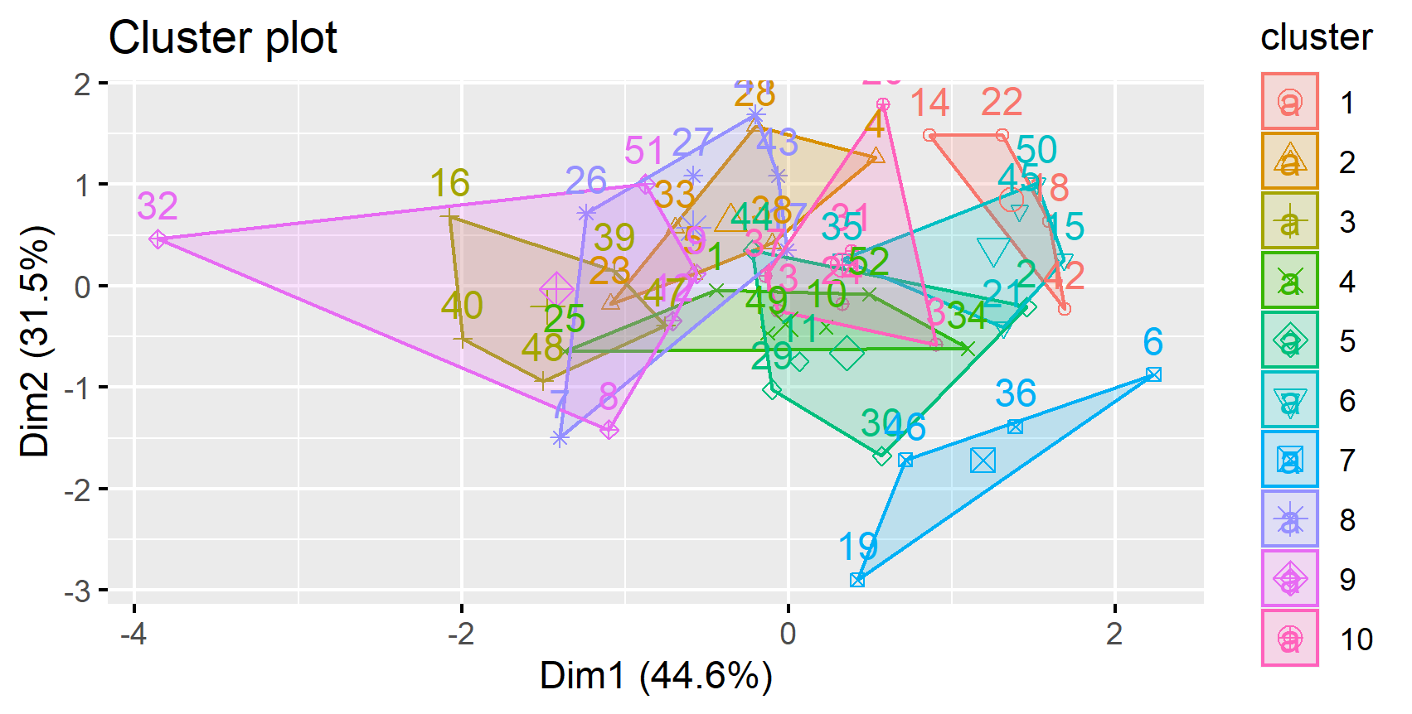

**6.2- The elbow plot after removing the outlier values**

* Within cluster sum of squares plot

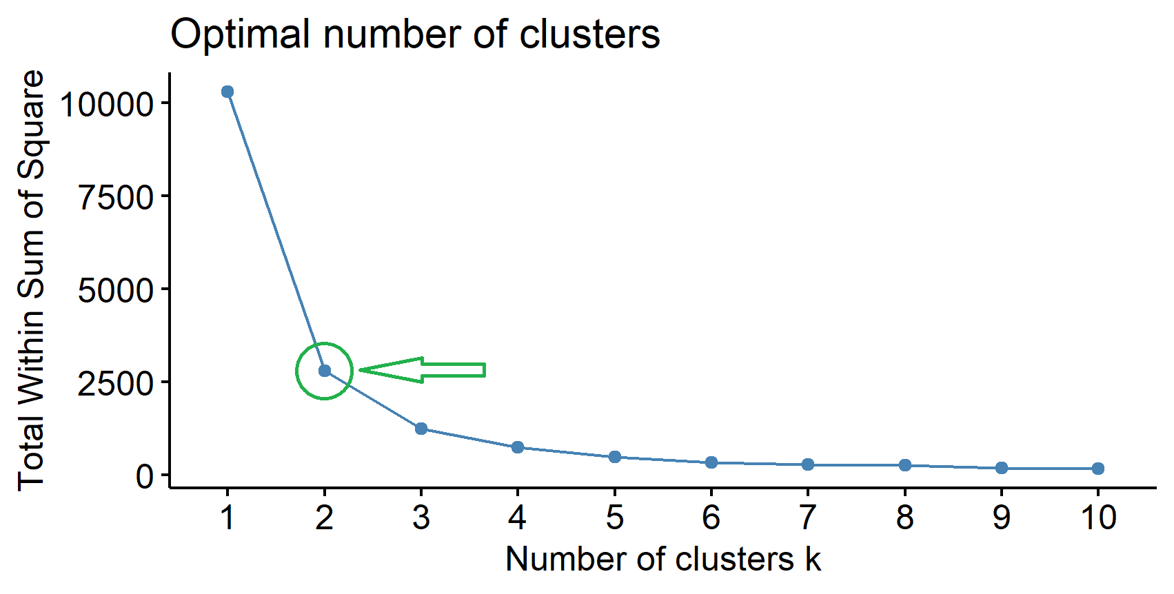

* Still the best choice of K equal 2. According to the elbow plot above.

**# Addition**

* **Cluster the data with the best choice of K = 2 and plot the result?**

